The external objects that interact directly with the system are called **actors*.*** Actors include humans, external devices and other software systems. The important thing about actors is that they are not under control of the application. In this project, user of the system is the actor.

To find use cases, for each actor, list the fundamentally different ways in which the actor uses the system. Each of these ways is a use case*.*

**6.3 Sequence Diagram**

A sequence diagram in a UML(Unified Modeling Language) is a kind of interaction diagram that shows how processes operate with one another and in what order. This shows the participants in an interaction and the sequence of messages among them. Each participant is assigned a column in a table.

Below section shows the sequence diagrams in this application

**6.3.1 Sequence Diagram 1**

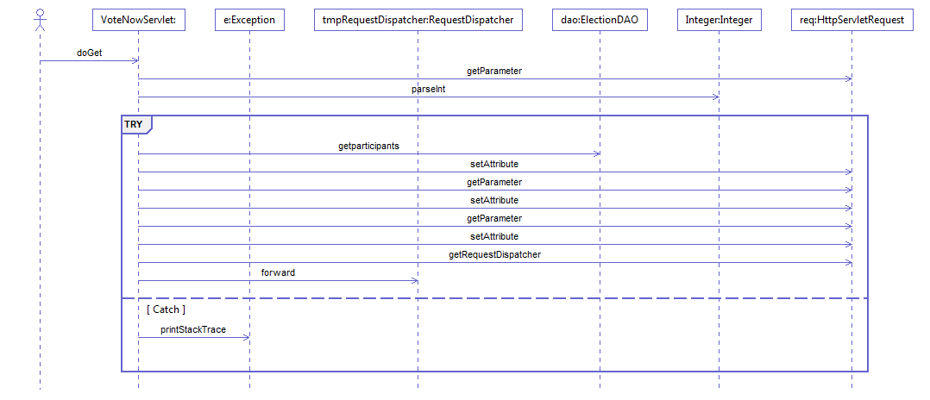

Figure 6.2 Voting Process

**6.3.2 Sequence Diagram 2**

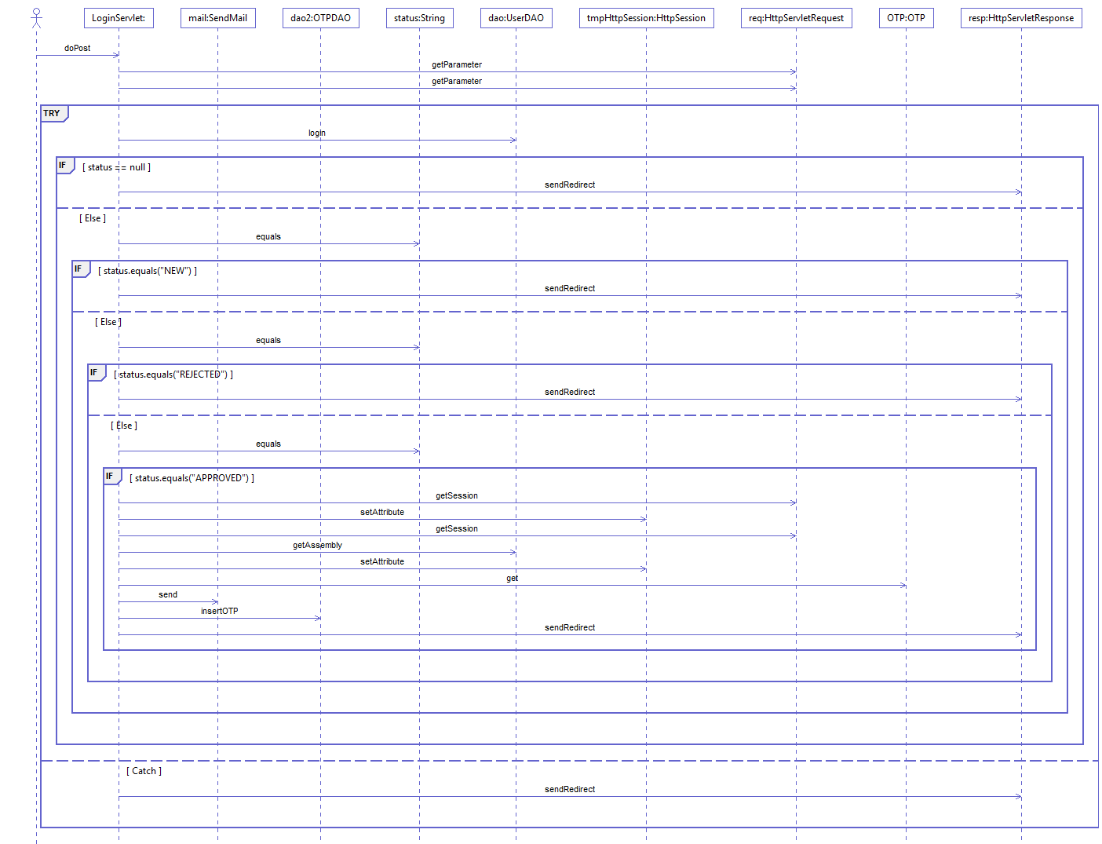

Figure 6.3 Login Process

**6.3.1 Sequence Diagram 3**

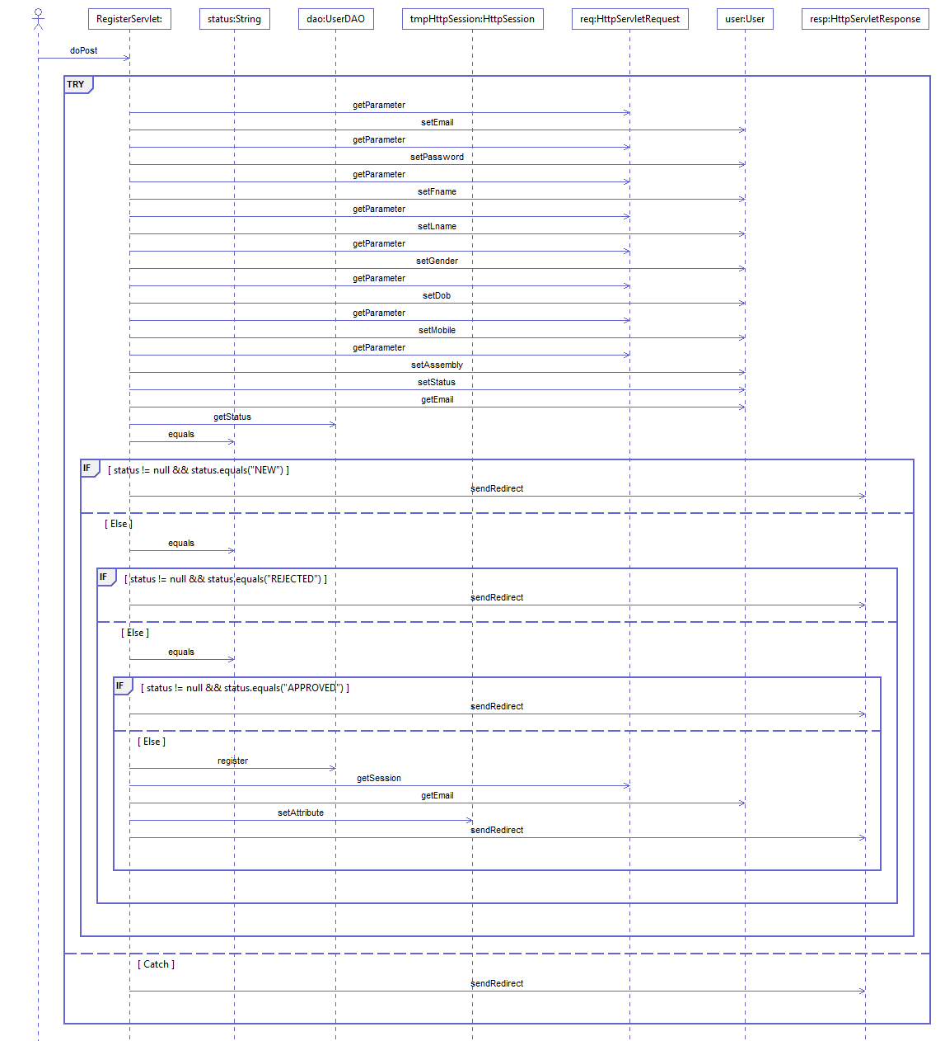

Figure 6.4 Registration Process

**6.3.1 Sequence Diagram 4**

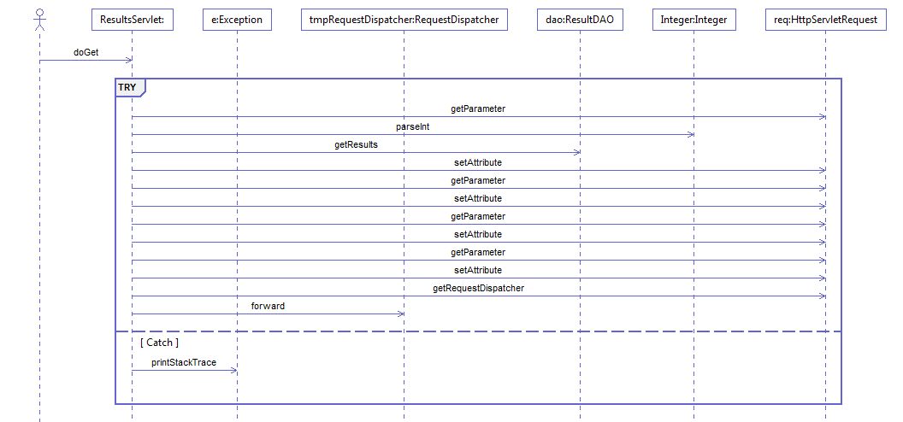

Figure 6.5 Getting the Results

**6.4 Class Diagrams**

A class diagram in the UML(Unified Modeling Language) is a type of static structure diagram that describes the structure of a system by showing the system's classes, their attributes, operations (or methods), and the relationships among the classes.

The class diagram is the main building block of object oriented modeling. It is used both for general conceptual modeling of the systematic of the application, and for detailed modelling translating the models into programming code.

Class diagrams can also be used for data modeling[1]. The classes in a class diagram represent both the main objects, interactions in the application and the classes to be programmed.

Below section shows the class diagrams of the application

**6.4.1 Class Diagram 1**

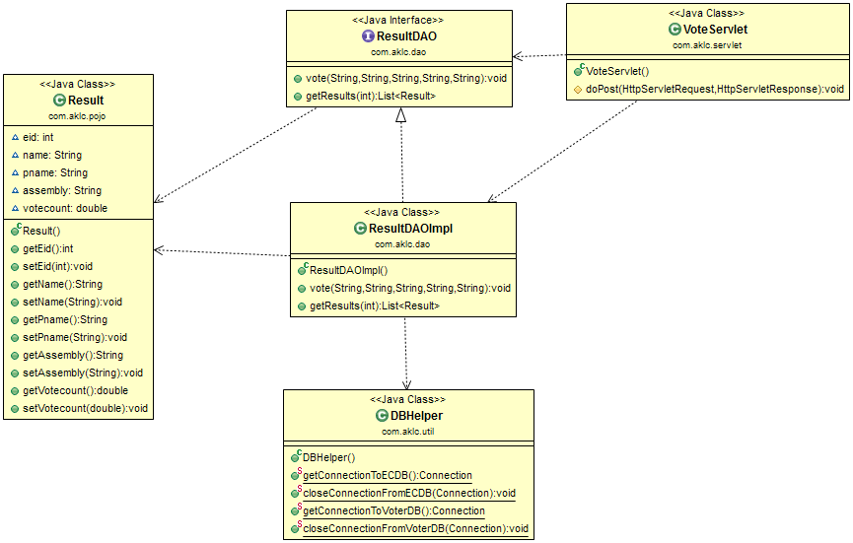

Figure 6.6 Class Diagram 1

**6.4.2 Class Diagram 2**

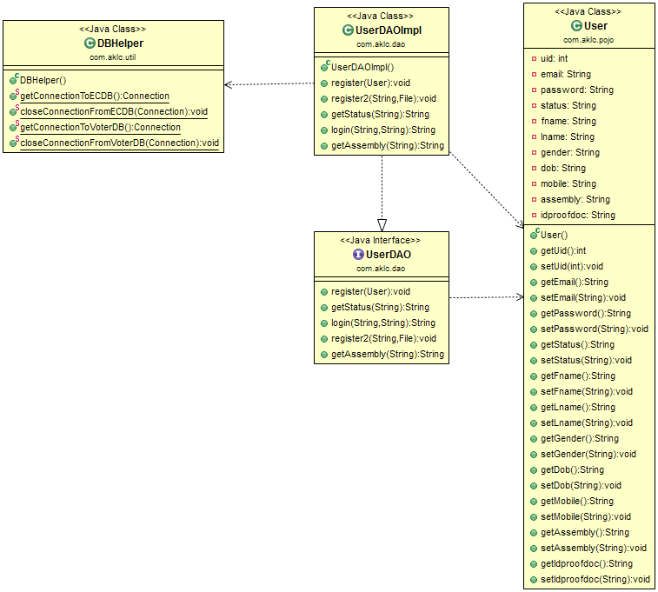

Figure 6.7 Class Diagram 2

**6.4.3 Class Diagram 3**

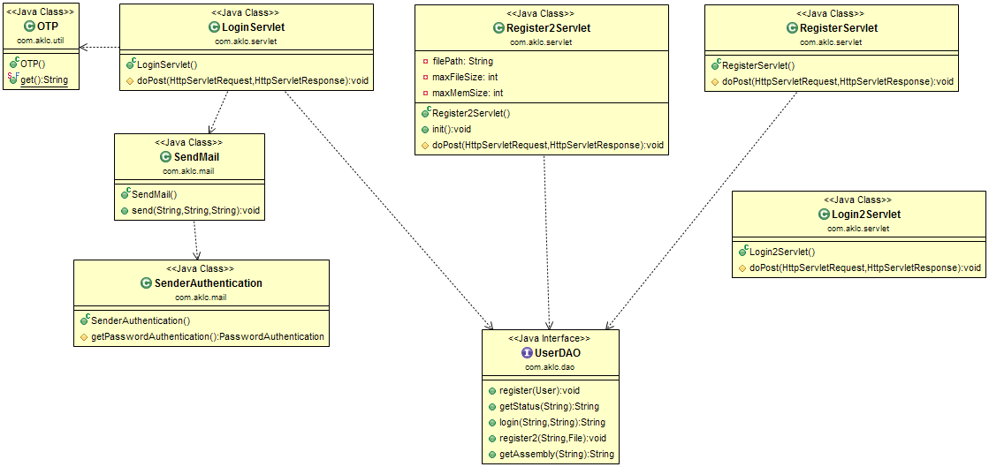

Figure 6.8 Class Diagram 3

**6.4.4 Class Diagram 4**

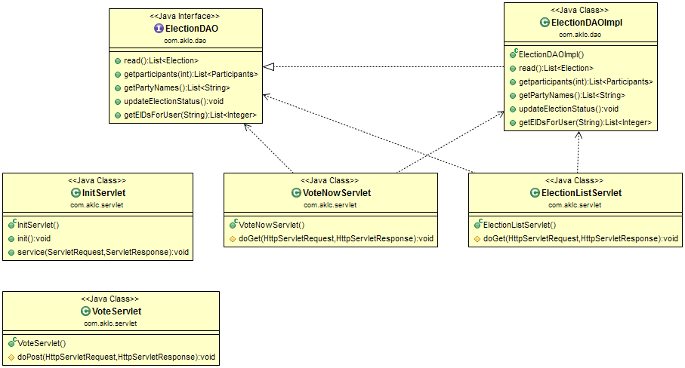

Figure 6.9 Class Diagram 4